PROJECT PREPROPOSAL

**Medication Take Back** (Team 1)

**Team Details:**

Team member 1: Vineetha Gummadi (15)

Team member 2: Vidyulatha Laksmi (26)

Team member 3: Sai Sampath Kumar Raigiri (41)

Team member 4: Veeresha M Thotigar (53)

**Project Goals and Objective**

Motivation of this project is to remove unused, unneeded, or expired medications from the home and dispose of them safely to prevent poisonings, prevent prescription drug abuse, and protect the environment.

Significance and objective of the system is to record all the features/details of the medications quantity prescribed and quantity remaining at the take back events and generates the reports for public awareness and research motive.

**System features:**

Medication take back is a web application and accessible by all the authorized members. System will have the features like,

* Gathering the details of the medication.
* Identification of the medicine.
* Generation of the report on daily, weekly, monthly ranges and based on the event place.
* The data is open to researchers to download.

**Project Plan using ZenHub tool:**

* We have created the milestones- Project Plan/Proposal, Increment 1, Increment 2, Increment 3.
* Assigned the tasks(issues) for each increment.
* Assigned the created tasks to each member in our team.
* Estimated the story points for each issue.

**Created Issues in ZenHub:**

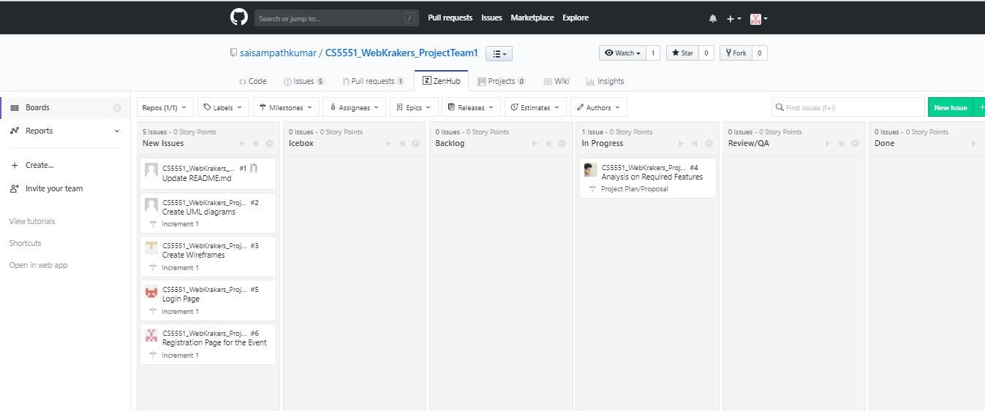

**Burndown Charts for Project Plan/Proposal Milestone:**

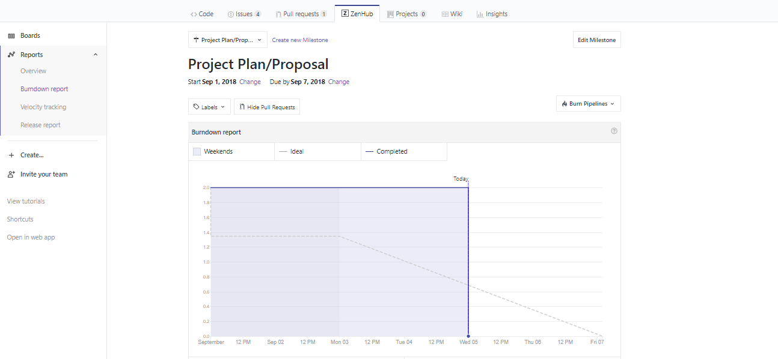

**Burndown Chart for Increment I Milestone:**

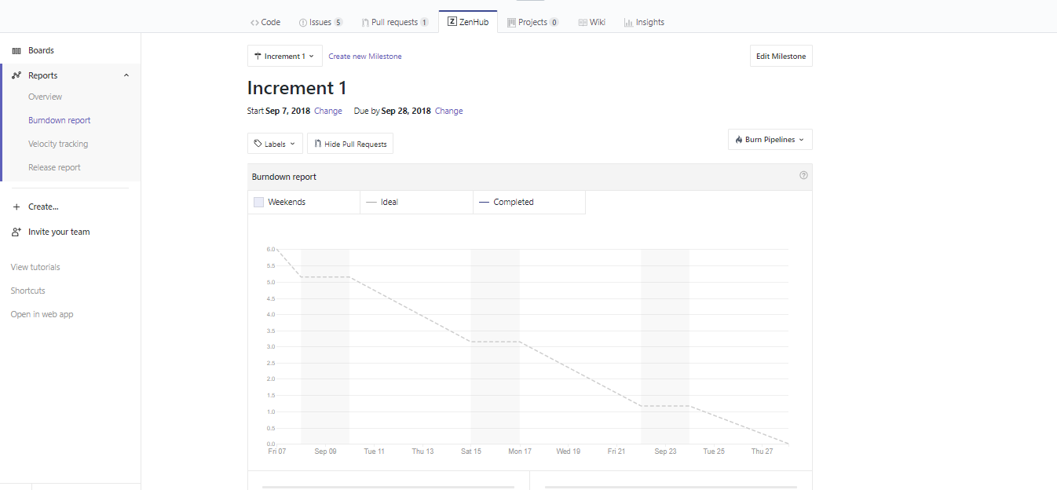

**Bibilography**

Reference - <https://texansstandingtall.org/pdfs/Rx%20takeback%20final.pdf>